Completing a Self Evaluation

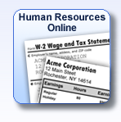 | Log into your MyPaychex.com account and choose the Human Resources Online program.
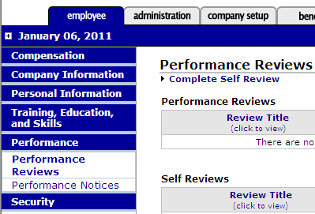 | Make sure you are on the Employee tab.  Under the Performance section on the left side, click on Performance Reviews.  Now in the main window click on Complete Self Review.  In this section you can also view any reviews your supervisor has completed.
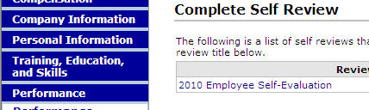 | Choose the 2010 Employee Self-Evaluation.
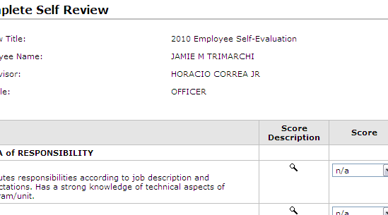 | Rate each item using the dropdown menu in the Score column.  (Shortcut: If you “tab” into this field, you can type the number you want.)  To see the rating definition, click the magnifying glass. Each rating has the same definition throughout the evaluation.
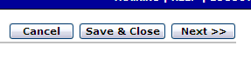 | On the right side of the click Next.
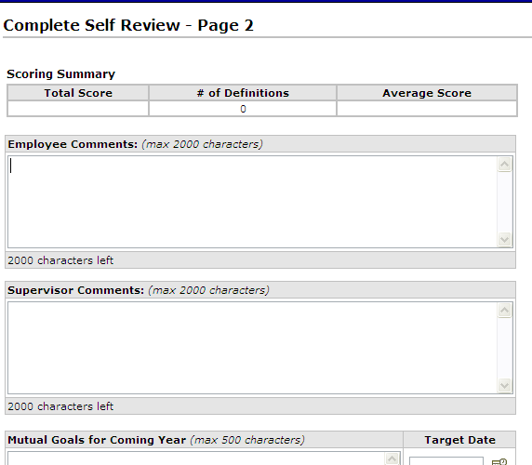 | Your average score will appear in the Scoring Summary section. This form does not give more weight to one section than another, unlike the form your supervisor will complete.  You may write in the Employee Comments section and/or attach a written memo to your supervisor’s review at a later time.  The Supervisor Comments and Goals sections will be completed by your supervisor on their review.
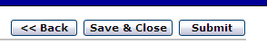 | When your review is complete, click Submit.
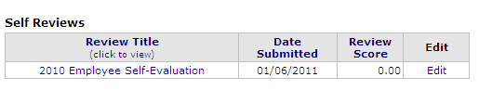 | You will be brought back to the Performance Reviews section. Click on your review to view it.  (There is an Edit option. This will be locked after Sunday, January 30.)
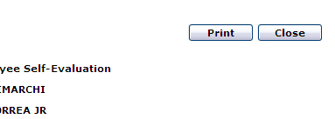 | Your review will come in a pop-up window. Click Print to print your review.  Your supervisor will be able to see and print your self-review when they log into their account, but they cannot edit or delete it.

